**5-1 Journal: Computer Science Trends and Artifact Update**

Christopher King

Southern New Hampshire University

CS-499 Computer Science Capstone 2024

Professor Conlan

December 1, 2024

**5-1 Journal: Computer Science Trends and Artifact Update**

**Part One:**

* **What is the significance of each trend?**
  + (AI and ML) Artificial Intelligence and Machine Learning are revolutionizing problem-solving by enabling systems to learn from data, identify patterns, and make decisions without human intervention. These technologies have transformative applications across industries, from healthcare to finance and transportation. Their significance lies in their ability to automate complex processes, improve decision-making, and foster innovation.
  + (BC Tech) Blockchain technology, best known for powering cryptocurrencies, is a secure, decentralized ledger system. Its significance extends beyond finance, offering solutions for transparency, security, and efficiency in sectors like supply chain management, healthcare, and governance.
* **How will each trend change the field of computer science?**
  + (AI and ML) AI and ML are changing the field of computer science by shifting the focus from traditional programming to data-driven methodologies. They encourage interdisciplinary approaches, combining computer science with statistics, neuroscience, and cognitive science. This trend pushes researchers and developers to innovate in areas such as natural language processing, computer vision, and predictive analytics.
  + (BC Tech) Blockchain is driving innovations in distributed computing, cryptographic security, and data integrity. It challenges computer scientists to rethink data storage and transaction models while creating opportunities for peer-to-peer applications.
* **How will each trend change the experience of consumers, workers, or citizens?**
  + (AI and ML) AI-powered applications enhance consumer experiences through personalized recommendations, virtual assistants, and automated services. Workers benefit from intelligent tools that streamline tasks and improve productivity. For citizens, AI is improving public services such as traffic management, healthcare diagnostics, and environmental monitoring, making society more efficient and resilient.
  + (BC Tech) For consumers, blockchain ensures transparency in transactions and data ownership. Workers in industries like logistics benefit from enhanced supply chain visibility, while citizens gain access to secure and transparent voting systems, among other applications.
* **How will each trend fit in with your career interests or aspirations?**
  + (AI and ML) As a software engineer, I am particularly interested in integrating AI into applications that improve user experiences and optimize processes. Understanding AI frameworks and algorithms aligns with my goal of creating intelligent, user-friendly solutions in fields like health tech and IoT.
  + (BC Tech) Blockchain aligns with my career interest in creating secure, scalable software systems. Its emphasis on decentralization and transparency resonates with my goal of designing systems that prioritize user trust and data security.
* **Which course outcomes have you achieved so far, and which ones remain?**
  1. At this point I believe I have achieved all aspects of the project. I have created seamless interaction between the front-end and MongoDB allowing the data to be pulled and displayed in an easy to read way. I have set up a web interface with an easy to use user interface that showcases what I have learned through out my college career. Next I will be focusing on the security side of the application. In hindsight I should focused on this throughout the entire project. I do have security measures in place, but I feel I can fine tune what I already have and add some more security.

**Part Two:**

* **Software Design and Engineering**
  + **Progress:** My updated app shows clear evidence of design improvements. The transition from java to a structured full-stack application demonstrates improvement on modern development paradigms.
  + **Next Steps:** Ensure design documentation aligns with enhancements to showcase the engineering process in the ePortfolio.
* **Algorithms and Data Structures**
  + **Progress:** The enhanced app implements encapsulation and the Factory Method, showcasing improvements in organizing and improving code efficiency.
  + **Next Steps:** Further optimize algorithms to handle large data or new animals for rescue operations.
* **Databases**
  + **Progress:** The use of MongoDB indicates the understanding of NoSQL databases. Current database interactions support storing and retrieving animal data efficiently. Expanded database schema to include additional data such as phases when in-training status is selected. This was done to align with the original specification document.
  + **Next Steps:** Adjust the view of the displayed data provided by the database.



**Screenshots on Enhancements made this Module:**

**Original Home Screen**



**Enhanced Home Screen (Logo and mission statement added)**

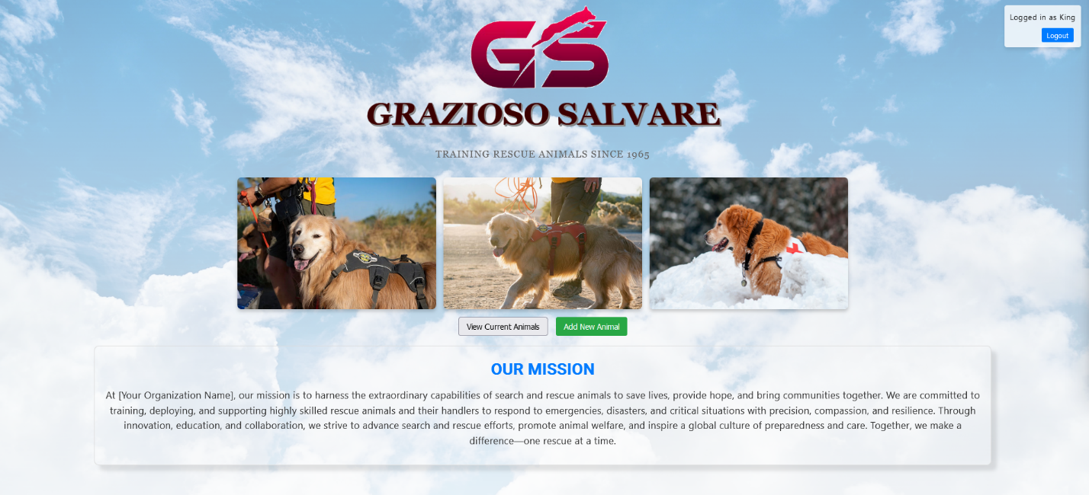

**Original Animal List**

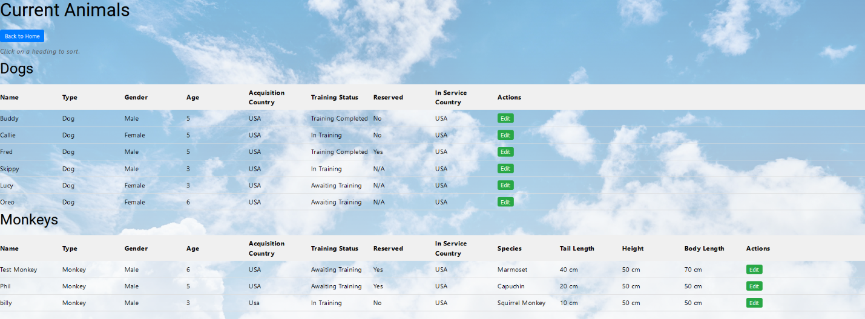

**Enhanced Animal List (Not Logged In)**

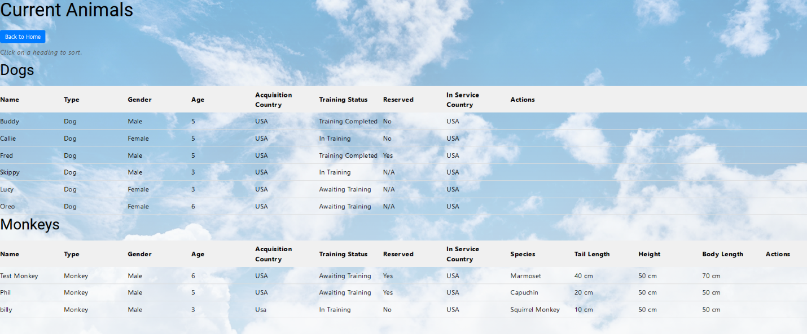

**Enhanced Animal List (Added/Cleaned up headings and added most used query buttons)**

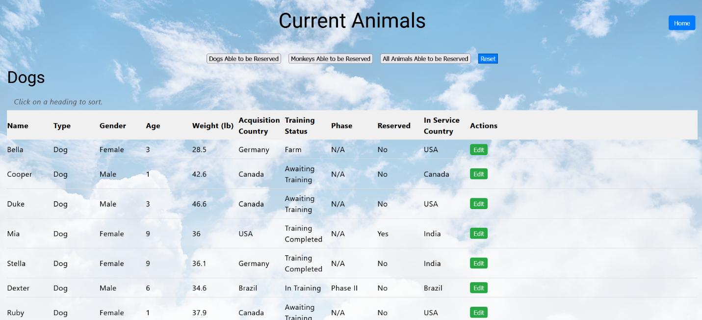

**Original Intake Form**



**Enhanced Intake Form (Added phases if in-training status is selected)**

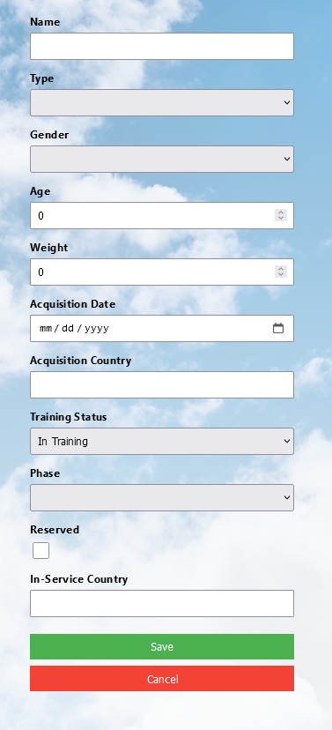

**Original Registration Screen**



**Enhanced Register Form (Now includes a registration code that will be required to register)**

